**DEPARTMENT OF MECHANICAL ENGINEERING  
  
Subject: Fundamentals of Programming  
Lab MANUAL: 8  
Submitted by: Muhammad Maaz  
Registration number: 479510  
Semester No. 1  
Date: November 30, 2023**

**FIRST TASK**

using namespace std;

float calculateAverage(const float array[], int size) {

float sum = 0;

for (int i = 0; i < size; ++i) {

sum += array[i];

}

return sum / size;

}

int main() {

int n;

cout << "Enter the size of the array: ";

cin>>n;

float* numbers = new float[n];

cout << "Enter " << n << " numbers:\n";

for (int i = 0; i < n; ++i) {

cout << "Number " << i + 1 << ": ";

cin >> numbers[i];

}

float average = calculateAverage(numbers, n);

cout<<"Average: "<<average<<endl;

delete[] numbers;

return 0;

}

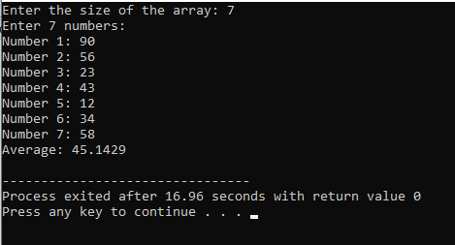

**SECOND TASK**

#include <iostream>

using namespace std;

int main()

{

int a, s = 5, arr[s];

cout<<"Enter "<<s<<" integers for array: ";

for (int i = 0; i<s; i++) {

cin>>arr[i];

}

for (int j = 0; j<(s-1); j++) {

for (int i = 0; i<(s-1); i++) {

if (arr[i]>arr[i+1]) {

a = arr[i];

arr[i] = arr[i+1];

arr[i+1] = a;

}

}

}

cout<<"Final Array: {";

for (int i = 0; i<s; i++) {

cout<<arr[i];

if (i == s-1)

continue;

cout<<",";

}

cout<<"}";

return 0;

}

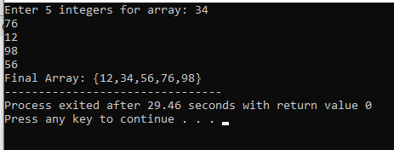

**THIRD TASK**

# include <iostream>

using namespace std;

int swap(int &a, int &b) {

int temp = a;

a = b;

b = temp;

}

int selectionSort(int arr[], int n) {

for (int i = 0; i < n - 1; ++i) {

int minIndex = i;

for (int j = i + 1; j < n; ++j) {

if (arr[j] < arr[minIndex]) {

minIndex = j;

}

}

swap(arr[i], arr[minIndex]);

}

}

int main() {

int n;

cout << "Enter the number of elements: ";

cin >> n;

int arr[n];

cout << "Enter the elements of the array:\n";

for (int i = 0; i < n; ++i) {

cin >> arr[i];

}

cout << "Array before sorting: ";

for (int i = 0; i < n; ++i) {

cout << arr[i] << " ";

}

selectionSort(arr, n);

cout << "\nArray after sorting: ";

for (int i = 0; i < n; ++i) {

cout << arr[i] << " ";

}

return 0;

}

